**Daily Scrum or Standup Meeting**

Team name: Group 2

Scrum Master: Max Edwards

Date: February 16 2023

| **Team Member** | **What did you do since the last scrum?** | **What do you plan to do before the next scrum?** | **What obstacles do you have?** |
| --- | --- | --- | --- |
| Satchell Fausett | Checked over story points. | Update money in user account | Review Django endpoint syntax |
| Jared Hansen | Material UI components | Polish the date display and mock/dummy submit button. | 3 other class projects  Understanding MUI components |
| Chase Miller | Redid the Django file strucutre | Create vehicle and create user endpoints  Return authentication boolean values | Calc 3 until Friday |
| Max Edwards | Use Context hook understanding and updated file structure | Finish NavBar  Finish making a login page with endpoint  /users/login/ | Learning Haskell  Work scheduling |
|  |  |  |  |

# Burndown

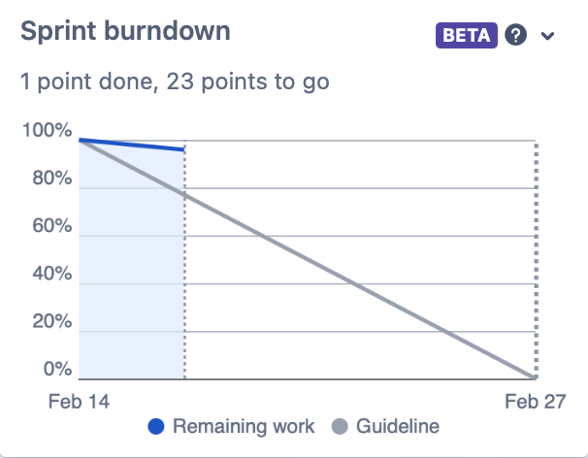

# 

# 

# 

# Screenshot of you project board